Information Architecture Lead — Role 3
1. Task Flow
The task flow describes the steps a user follows to complete the main task in the system: selecting an item and completing an order.
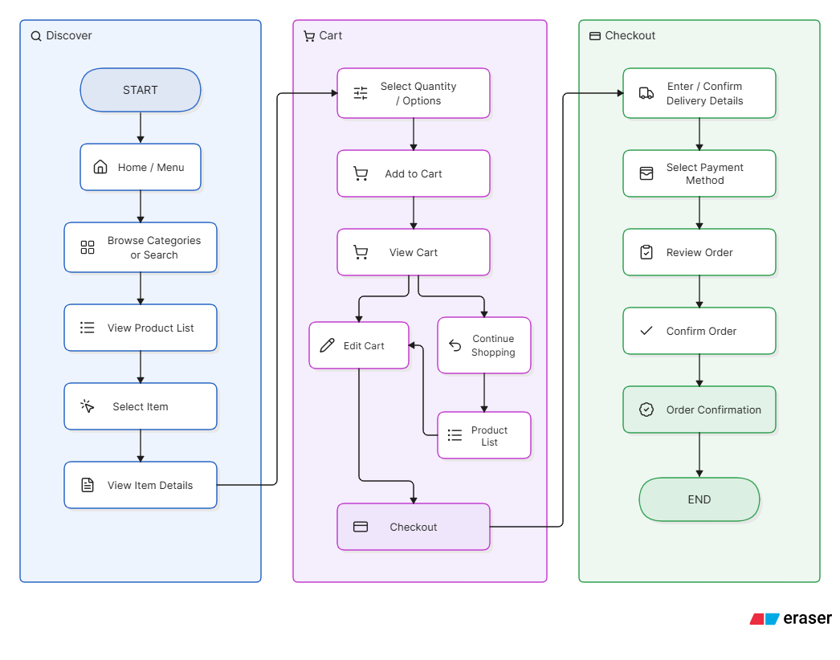

Task Steps
- User opens the application.
- User views the Home/Menu screen.
- User browses categories or searches for an item.
- User views the available products.
- User selects an item.
- User views the item details.
- User selects the required quantity/options.
- User adds the item to the cart.
- User reviews the cart.
- User edits the cart or continues shopping if necessary.
- User proceeds to checkout.
- User enters or confirms delivery details.
- User selects a payment method.
- User reviews the order.
- User confirms the order.
- System displays order confirmation.

2. User Journey
The user journey shows what the user does, what they need, and how the system responds at each stage.
Stage | User Action | User Need | System Response
1. Discover | Opens the application | Know what is available | Displays Home/Menu
2. Browse | Selects a category or searches | Find the required item | Displays relevant products
3. Evaluate | Selects a product | Understand the product | Displays item details, price and options
4. Select | Chooses quantity/options | Prepare the purchase | Updates item selection
5. Add | Clicks Add to Cart | Save the selected item | Adds item to cart and updates cart
6. Review | Opens the cart | Check selected items and total | Displays cart contents and total
7. Checkout | Selects Checkout | Complete the purchase | Opens checkout
8. Delivery | Enters/confirms details | Provide delivery information | Validates and saves details
9. Payment | Selects payment method | Pay for the order | Displays payment options
10. Confirm | Reviews and confirms order | Ensure information is correct | Processes order
11. Complete | Views confirmation | Know the order was successful | Displays confirmation and order details

3. Interaction Flow
The interaction flow shows how the user moves between screens and how the system responds to user actions.
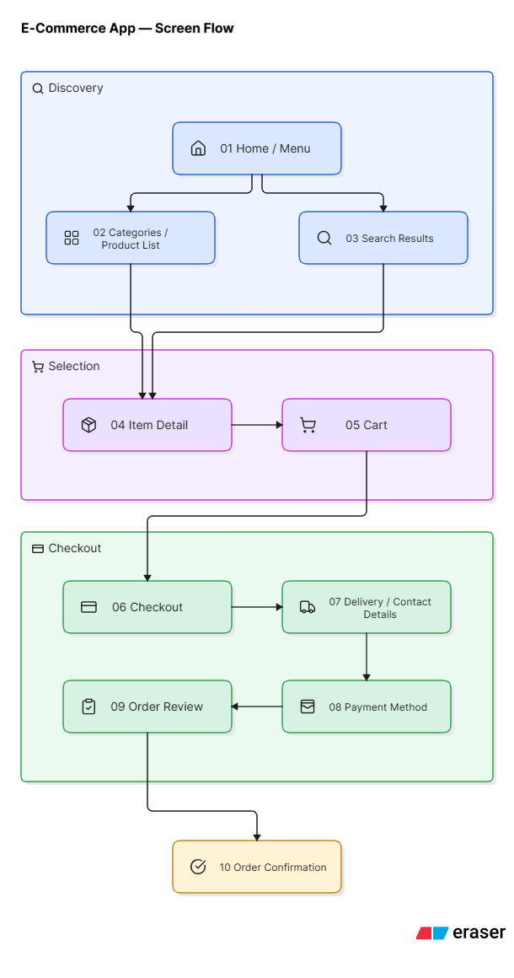
Main Interactions
- Home → Categories/Search: User chooses how to find an item.
- Product List → Item Detail: User selects a product.
- Item Detail → Cart: User adds the selected item.
- Cart → Product List: User can continue shopping.
- Cart → Checkout: User starts the purchasing process.
- Checkout → Delivery: User provides or confirms delivery information.
- Delivery → Payment: User selects a payment method.
- Payment → Order Review: User checks the complete order.
- Order Review → Confirmation: User confirms the order.
- Confirmation → Home: User can return to the main application.

4. Screen Map
The screen map defines the screens required for the system and how they are connected.
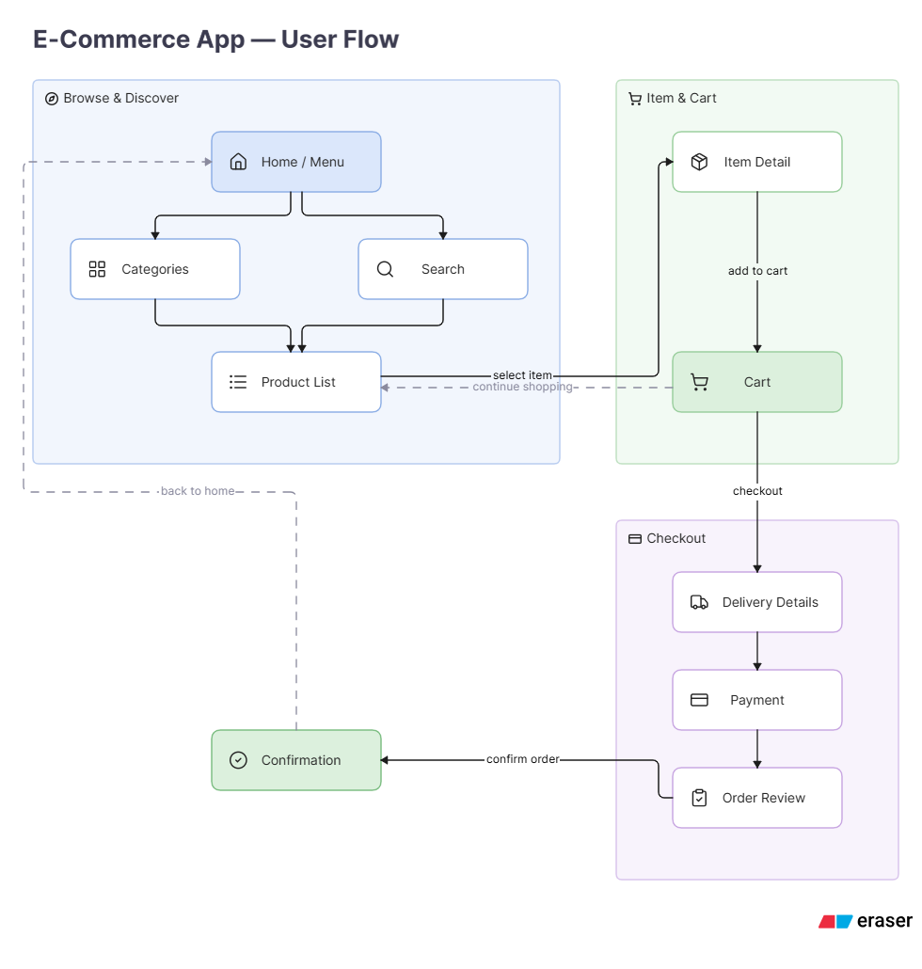

Home/Menu
├── Categories → Product List → Item Detail
├── Search → Search Results → Item Detail
└── Cart

Item Detail → Cart

Cart → Product List (Continue Shopping)
Cart → Checkout

Checkout → Delivery Details
Delivery Details → Payment
Payment → Order Review
Order Review → Order Confirmation
Order Confirmation → Home/Menu

